Salesforce Org Review

Grainger

Version 1.0
July 26, 2024

Contents
1 Introduction 2
1.1 Overview 3
2 Detailed Findings 3
2.1 Org Summary 4
2.1.1 Review of licenses by type, purchased, and use 4
2.1.2 Data and File usage 6
2.1.3 Daily API Requests 7
2.1.4 Sandboxes 7
2.2 ORG HEALTH AND OPTIMISER CHECKS 8
2.2.1 Running of a Health Check 8
2.2.2 Running of an optimizer check 10
2.2.3 Running of release updates 16
2.3 Review of the Data Model 17
2.4 Review of the Security and sharing Model and general org security 17
2.4.1 Security Model 17
2.4.1.1 Profiles & Permission Sets Recommendations 18
2.4.2 Sharing Model 18
2.4.3 Allowed Email Domains 25
2.4.4 Single Sign-On and Multifactor Authentication (MFA) 25
2.5 User Provisioning 26
2.5.1 User Provisioning Observations 26
2.5.2 User Provisioning Recommendations 26
2.6 Review of all declarative automations 26
2.6.2 Observations 27
2.6.3 Recommendations 27
1.6 Apex Code 28
2.6.1 Code Quality 28
2.6.2 Apex Test Code Coverage 29
2.7 Review of page layouts and general user experiences 29
2.7.1 Recommendations 29

Introduction

Overview
Open Box Software has completed a review of the Grainger Salesforce production org with the aim of getting a better understanding of the current org state and to identify potential risks and challenges that may affect performance, security, scalability and flexibility to accommodate future enhancements.
The review has been conducted with a moderately comprehensive depth of understanding and a reasonable level of effort; however, it should not be regarded as exhaustive.
The tasks undertaken as part of this review included the following:
- Review of licenses by type and usage
- Review of data usage
- Running a Health Check
- Running of an Optimizer Check
- High level review of the Security and Sharing Model
- High level review of all automations
- Static code analysis of all Apex code performed using Apex PMD
- Execution of all Apex test classes with review of code coverage and failures

Detailed Findings
A review of a mature Salesforce org (20 years) used by a large enterprise typically produces a large number of findings and actions to be taken of varying importance and priority. These findings are fully documented in the following sections so that the Grainger team understands the current health of their org.
The findings that follow are presented as observations or recommendations.
- Observations require no action and are intended to provide confirmation that the org is following best practice.
- Recommendations are given where there may be some action required to improve the overall security, quality or performance of the org.

Org Summary

Review of licenses by type, purchased, and use
The Grainger org was provisioned in 2019 It is an Enterprise Edition org with single GBP currency.
The below table details the current license state
License Name | Profile or Permission Set License | Licenses bought | Licenses used | Licenses available for allocation
Salesforce |  | 236 | 230 | 6
Partner Community |  | 40 | 36 | 4
Salesforce Integration |  | 5 | 4 | 1
Identity |  | 100 | 0 | 100
 | Status | Total Licenses | Used Licenses | Remaining Licenses
  Profile or Permission Set License
Your Account App | Active | 100 | 0 | 100
Trust Card Manager | Active | 10,000 | 0 | 10,000
Standard Einstein Activity Capture User | Active | 100 | 1 | 99
Slack Service User | Active | 235 | 0 | 235
Service User | Active | 235 | 0 | 235
Service Catalog Guest Access | Active | 100 | 0 | 100
Service Catalog Access | Active | 235 | 0 | 235
Salesforce API Integration | Active | 5 | 4 | 1
Sales User | Active | 1 | 0 | 1
Sales Engagement Basic | Active | 100 | 0 | 100
Sales Console User | Active | 1 | 0 | 1
Remote Data Cloud | Active | 1,000 | 0 | 1,000
Pipeline Inspection | Active | 1 | 0 | 1
Partner Messaging User | Active | 5 | 0 | 5
Messaging User | Active | 5 | 0 | 5
Messaging for In-App and Web User | Active | 5 | 0 | 5
Industry Service Excellence | Active | 235 | 0 | 235
Inbox | Disabled | 0 | 0 | 0
Enablement Lite | Active | 15 | 0 | 15
Employee Management | Active | 235 | 0 | 235
Employee Access | Active | 235 | 0 | 235
Einstein Search | Active | 236 | 0 | 236
Einstein Conversation Insights Standard | Active | 10 | 0 | 10
Einstein Agent CWU | Active | 235 | 0 | 235
Einstein Agent | Active | 235 | 0 | 235
Dialer Outbound User | Disabled | 0 | 0 | 0
Dialer Inbound User | Disabled | 0 | 0 | 0
Decision Explainer Permission Set License | Active | 235 | 0 | 235
Conversation Insights Integration User | Active | 10 | 0 | 10
Company Community for Force.com | Disabled | 0 | 0 | 0
Code Builder | Active | 65 | 0 | 65
Business Rules Engine Runtime | Active | 235 | 0 | 235
Business Rules Engine Designer | Active | 235 | 0 | 235
Analytics Template Administration | Disabled | 0 | 0 | 0
(Retired) Salesforce Mobile Chat Experience | Disabled | 0 | 0 | 0

Observations
- Some of the licenses and/or permission set licenses are allocated to Enterprise Edition orgs by default (i.e. no extra cost). These include, for example, Chatter Free, Chatter External, Einstein Activity.

Recommendations:
- Code builder package can be installed and used for the advantage of development teams.
- Use of Business Rules Engine can be explored to support day to day Grainger business processes

Data and File usage
Available data storage = 12.7 GB total
Used data storage = 12.7 GB/14.8 GB or 86%

Available file storage = 162,1 GB total
Used data storage = 162.1 GB/505.0 GB or 32%

Data Storage

Observations
- With 86% of data storage capacity used, the organization is nearing its storage limit, which could lead to potential additional costs if storage needs exceed current limits. Data storage has reached 86% of limit.

Recommendations

Implement data archiving solution

File Storage

Observations

At 32% utilization, file storage is well within limits and indicating ample future capacity and efficient usage.

Daily API Requests
Available API requests per 24h = 344,000

Used daily API requests (as on day month 202.) = 42325 (12%)

Daily API Requests Observations
- Daily API requests are well within limits.
- There is ample room for increased API activity, which can accommodate future growth in integrations or data exchanges without immediately impacting system performance or incurring additional costs.

Sandboxes
Available Sandbox Licenses
Developer  8/50 Used | Developer Pro  0/0 Used | Partial Copy  1/2 Used | Full  1/1 Used

Sandbox Observations
- Developer Sandboxes: There is significant capacity available with 19 unused licenses, indicating ample room for additional development and testing environments.
- Partial and Full Copy Sandboxes: All licenses are fully utilized, indicating that current testing and staging environments are fully in use.

Sandbox Recommendations
- Apex script can be developed to auto populate Unit lookup on Product records

ORG HEALTH AND OPTIMISER CHECKS

Running of a Health Check
Salesforce an automated “Health Check to identify and fix potential vulnerabilities in your security settings, all from a single page. A summary score shows how your org measures against a security baseline.
The outputs of a Health Check are as follows:
- A baseline standard percentage and rating 84% (Very good)
- A list of “High-Risk”, “Medium-Risk”, and “Low-Risk recommendations with High-Risk items being recommended for immediate action
The following tables list the risks that have been found within the Grainger org

High-Risk
Status | Setting | Your Value | Standard Value | Actions | Recommended Steps
Critical | Number of Objects with default external access to Public | 61 | 0 | Review Sharing Settings | Review all objects with external Read/Write access. Use Sharing Rules to share records with external and internal users wherever possible.

Medium-Risk
Status | Setting | Your Value | Standard Value | Actions | Recommended Steps
Critical | Require a minimum 1 day password lifetime | Disabled | Enabled | Review password policies | Review company password policies and enable the setting to improve security.
Critical | Enforce login IP ranges on every request | Disabled | Enabled | Review Session Settings | With SSO enabled, it is recommended to keep this setting as is
Critical | Administrators Can Log in as Any User | Enabled | Disabled | Review Login Access Policies | It is important to consider the inconveniences for administrators when attempting to solve issues for users. It is recommended to keep this setting as is.
Warning | Password complexity requirement | Must include alpha and numeric characters | Must include alpha, numeric, and special characters | Review password policies | Review company password policies and add a security question.

Low-Risk
Status | Setting | Your Value | Standard Value | Actions | Recommended Steps
Critical | Obscure secret answer for password resets | Disabled | Enabled | Review password policies | To improve security, it is recommended to enable this setting. This could grant access to unauthorized users.
Warning | Lockout effective period | 15 minutes | 30 minutes | Review password policies | Review company password policies and increase the lockout period to improve security.

Based on the risks identified above our recommendation is to review the sharing settings and minimize External read/write access on objects.

Observations
- Salesforce Health Check identified several areas needing improvement, with the current score at 84% (Very good).

Recommendations
- Prioritize resolving the high-risk items identified in the Health Check, as these represent critical security vulnerabilities requiring immediate action.
- Next, address the medium-risk issues, integrating them into your update schedule based on their potential impact.
- Finally, review and address the low-risk items as part of ongoing security improvements. While these are less urgent, resolving them will contribute to a more robust security posture.
- Continuously monitor your Health Check score, assess the effectiveness of implemented changes, and stay updated with Salesforce releases and security patches.

Running of an optimizer check
The Salesforce Optimizer check analyses features in an interactive and actionable format. It allows for the identification of issues that require immediate attention

The results of the Optimizer Check are as follows:
Feature | Type | Status | Recommended Action
Active Workflow Rule Limits | Object Limits | Immediate Action Required. | Convert Workflow rules to Flows.
User Logins | User Management | Immediate Action Required. | List of users not logging into Salesforce. User adoption should be encouraged.  Review users to determine whether these users need access to Salesforce. Deactivate accounts of former employees or anyone who doesn’t need to access Salesforce.
Insecure Default External Access Levels | Improve Org Security | Immediate Action Required. | Review objects with external Read/Write access.  Set more restrictive external access levels for these objects on the Sharing Settings Setup page. These sharing rules, sharing sets, or manual sharing can be used to extend record access to external users as required.
Insecure Community Sharing Settings | Improve Org Security | Action Required. Portal and Site User visibility is enabled. | Review the “ See other members of this site” and “ Let guest users see other members of this site” settings.
Details Tab on Record Pages | Fields | Action Required. | There is a high number of fields on this tab, and performance can be increased by moving the Details tab so that it’s not shown by default on a Lightning record page.  Example - Opportunity record page has 219 fields added. Review and simplify the page.
Profile Assignments | User Management | Action Required. | Review and delete unused profiles. There are 9 unassigned custom profiles mentioned in profiles.csv file attached.
Fields on Page Layouts | Fields | Action Required. There are 6 page layouts contain a very high number of fields. This include Opportunity, Unit, Parking/Garage, Shed etc. | Review the fie Custom fields that your users don’t use or need must be deleted. lds on Opportunity, Unit, Parking/Garage, Shed. Delete fields that users don’t use.  Use Dynamic forms.
Custom Field Limits | Object Limits | Action Required. | Custom fields that your users don’t use or need must be deleted. Opportunity object has high number of custom fields i.e. 355. Limit is 500.
Critical Permission Assignments | User Management | Action Required. | Review assignment of following permissions via permission set or profiles and analyse if truly needed:  - Manage All Data  - View All Data  - Customize Application  - Manage Encryption Keys  - Reset User Passwords and Unlock Users  - Manage Password Policies  - Manage Profiles and Permission Sets  - Assign Permission Sets  - Password Never Expires  - Manage Roles  - Manage Internal Users  - Manage Users  - Author Apex  - Manage Sharing  - Multi-Factor Authentication for User Interface Logins
Pending Release Updates | Improve Org Security | Action Required. | Review of the org and complete the recommended tasks to prepare your org for the update enforcement. There are 20 release updates that need action.
Migrating Workflow Rules to Flow Builder | Workflow | Action Required. | Workflow rules need to be replaced by creating flows using Flow Builder. There are 140 workflow rules that you can replace with a flow.
Unassigned Permission Sets | User Management | Review Required. | Review and delete following unassigned permission sets:  - Trail tracker Badges  - Referencing HL Callout  - cases Permission Set  - Azure  - Email edit permission
Unassigned Custom Profiles | User Management | Review Required. | Review and delete following unassigned profiles:  - Customer Service Advisor  - Renewal Team  - Trail Tracker  - TPT Manager  - Renewal Manager  - Tenancy Progression  - TPT Team  - WebApp Integration User
Incomplete Chatter Profiles | Usage | Review Required. | Make users who haven’t completed their profiles, aware that they have to update their information. Monitor your org’s Chatter engagement with Chatter dashboards.
Field Usage | Fields | Review Required. | Review and delete the fields that are not used. Detailed analysis presented in attached file CustomFields.csv
Unassigned Roles | User Management | Review Required. | Delete roles that don’t have active users assigned to them.
Unassigned Page Layouts | Custom Layouts | Review Required. | Delete unassigned page layouts in your implementation. If you need to keep the page layout, assign it to a record type. There are 9 page layouts that aren’t assigned to a record type. Detailed analysis presented in attached file CustomFields.csv
Permission Sets with a Low Number of Users | User Management | Review Required. | Consolidate permission sets that have a low number of active users, and delete the permission sets that you no longer need.
Lightning Components on Record Lightning Pages | Custom Layouts | Review Required. | Review and minimize the number of components used on page layout. Example - Unit record page includes 16 components. Too many components on a page can cause it to load slowly.
Notes and Attachments Related List | Custom Code | Review Required. | Convert your existing notes and attachments to Salesforce Files with the Attachments to Files app. Then, on all your page layouts, replace the Notes and Attachments related list with the Files related list.  There are 3 page layouts that use the Notes and Attachments related list.  - Break Clause Layout  - Right to Rent Layout  - End of Tenancy Phase Template Layout
Disable Debug Mode | Custom Code | Review Required. | Salesforce is slower for users who have debug mode enabled, so it is recommended to determine which users are actively debugging JavaScript first. Then, disable debug mode for those who aren’t debugging. For those who are actively debugging, debug mode makes it easier to debug JavaScript code from Lightning components.
Inactive Chatter Users | Usage | Review Required. | Remind users who haven’t logged in to Chatter recently to check their accounts regularly. Monitor your org’s Chatter engagement with Chatter dashboards.
Unused Dashboards | Reports And Dashboards | Review Required. | Delete the dashboards that you no longer need. Only dashboards that admins have access to should be analyzed.
Files Adoption | Usage | Review Required. Files not being used. | Make sure Files related list is added to the page layouts. Encourage Files usage.
Inactive Validation Rules | Workflow | Review Required. | Delete inactive validation rules. There are 4 inactive validation rules on Opportunity.  - Closed_Won_Active_OCR_have_R2R  - Closed_Won_Move_in_Monies  - Unit_of_Interest_required  - Cannot_edit_start_date_of_a_schedule
Custom Profiles with a Low Number of Users | User Management | Review Required. | Consolidate profiles that have a low number of active users, and delete the profiles that you no longer need. There are 5 custom profiles that have a low number of users.  - Data Support - 1  - Grainger User Lettings - 2  - Grep Integration User - 2  - Integration User – 3  - Lettings Manager - 4
Multiple Apex Triggers per Object | Custom Code | Review Required. | No action required. These are unmanaged and managed package triggers. Not possible to merge.
Active Validation Rule Limits | Object Limits | Review Required. | Analyse and make sure number of validation rules per object is within limit.
Convert Attachment to Files | Custom Code | Review Required. | Convert existing attachment records to Files.
API Versions | Custom Code | Review Required. | Analyse the api version of existing apex classes, pages and components. Upgrade api version.
Unused Reports | Reports And Dashboards | Review Required. | Delete the reports that you no longer need.
Path | Improve User Experience | Not Currently Enabled
Macros | Improve User Experience | Not Currently Enabled
Active Sharing Rule Limits | Object Limits | No Action Required
News and Twitter | Custom Layouts | No Action Required
Record Types per Object | Custom Layouts | No Action Required
Page Layouts per Object | Custom Layouts | No Action Required
Unsupported Browsers | Usage | No Action Required
S-Controls | Custom Code | No Action Required
Public Groups and Queues with Guest Users | Improve Org Security | No Action Required
My Domain | Improve User Experience | No Action Required
Inactive Workflow Rules | Workflow | No Action Required
Omni-Channel | Improve User Experience | No Action Required
Duplicate Management | User Management | No Action Required
Hard-Coded URLs | Custom Code | No Action Required
File Storage Limits | Org Limits | No Action Required
Static Resource Limits | Org Limits | No Action Required
Lightning Service Console | Increase User Adoption | No Action Required
Sharing Rules for All External Users | Improve Org Security | No Action Required
Replacing Related Lists with the Related List Quick Links Component | Custom Layouts | No Action Required
Out-of-Date Browsers | Usage | No Action Required
Unassigned Record Types | Custom Layouts | No Action Required
Data Storage Limits | Org Limits | No Action Required
New Code Using Old API Versions | Custom Code | No Action Required
Formula Fields with JavaScript Code | Custom Code | No Action Required

File attached OptimizerRun.xls.

- Observations
- There are a number of items reported by the Optimizer that recommend action or review. Many of these have already been covered in other sections of this document (e.g. private OWD for external sharing, profiles and permission sets etc.).

- Recommendations
- The critical actions of the optimizer check have already been covered by other sections in this document, but the Grainger administrator should review above table for full visibility.

Running of release updates
The Salesforce Release Updates check reviews and activates release updates to improve org performance, security, business logic, and usability. It allows for the identification of issues that require immediate attention

Observations
- There are 20 Salesforce Release Updates that require immediate or future action by the end of February 2025 to enhance the performance, security, and usability of your Salesforce org.

Recommendations
- It is recommended that these updates should be applied in UAT, tested and deployed to PROD as part of the scheduled weekly hotfixes. It is recommended to avoid applying all releases at once so that any unexpected impact can be more easily isolated and resolved.

Review of the Data Model
Open Box has reviewed the data model of Grainger Salesforce org to understand it and the relationships that exist fully. The following is an org schema that shows key objects within the data model
TBD - (Insert Lucid Chart Data Model Export here)

Review of the Security and sharing Model and general org security
Open Box has completed a review of the Security Model of Grainger Salesforce org. The findings are as follows:

Security Model
Security relates to the objects and fields that a user has access to via the assignment of a profile and permission sets. The following are tables of the profiles and permission sets within of Grainger org.

Profiles
Profile Name | Description | Amount of users assigned
Attached File Check Tab name – Profiles with Low Assignments
Check above attached file – OptimizerRun.xls. Tab name – Unassigned Profiles

Permission Sets
Permission Set Name | Description | Amount of users assigned
Check above attached file – OptimizerRun.xls. Tab name – Low assigned PermissionSets
Check above attached file – OptimizerRun.xls. Tab name – Unassigned PermissionSets

2.4.1.1 Profiles & Permission Sets Recommendations
- Remove unused custom profiles and permission sets, making it easier for setting up new users and user administration in general
- Start planning to migrate from profiles to permission sets in line with Salesforce best practices of Permission Sets being used instead of profiles

System Administrator Profile Observations
- Currently 4 users have the System Administrator profile.

System Administrator Profile Recommendations
- Each of the System Administrator users should be reviewed to determine if they are genuinely system administrators with the requisite Salesforce experience to be responsible for a production org. If System Administrator access is not required, reassign users to another profile and use permission sets to provide the desired access level.

Recommendations for Security Model
- Determine and delete unused custom profiles like Trail Tracker, Webapp Integration User, Renewal Manager etc.
- Determine and delete unused permission sets like DMTracking, Email_edit_permission etc.

Sharing Model

Organizational Wide Defaults (OWD)

Observations
- There are a number of objects which have a “Public Read/Write” OWD which is against best practice of using the principle of least privilege.
- Currently, there are 67 objects that have external access of Public Read/Write. This is a potential security risk and a further understanding of the requirement for external access should be undertaken and changes made accordingly.

Recommendations
- Depending on the business requirements, internal users may require public read/write access to an object. However, it is recommended to apply the principle of least privilege and ensure that users have access only to the data relevant to their role and responsibilities. This reduces the risk of data loss (e.g. a disgruntled employee exporting all opportunity and contact data) and data security (e.g. certain financial data may be confidential).
- If there is no requirement for external access (i.e. there are no active Experience Cloud sites), it is recommended that external access be set to Private
- 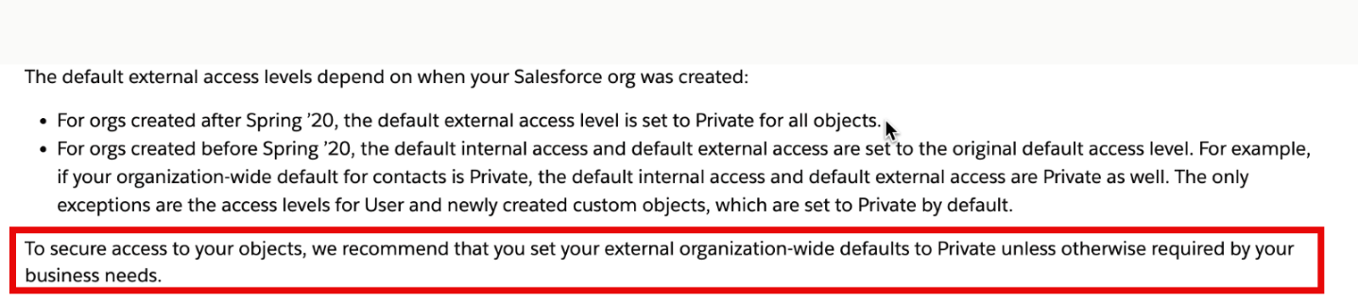
The following details all of the above for (insert client name) org

Organizational Wide Defaults
Object Name | Internal Access | External Access
Lead | Public Read/Write/Transfer | Private
Account and Contract | Public Read/Write | Private
Contact | Controlled by Parent | Controlled by Parent
Order | Controlled by Parent | Controlled by Parent
Asset | Controlled by Parent | Controlled by Parent
Opportunity | Public Read/Write | Private
Quote | Controlled by Parent | Controlled by Parent
Case | Public Read/Write/Transfer | Private
Campaign | Public Full Access | Private
Campaign Member | Controlled by Campaign | Controlled by Campaign
User | Public Read Only | Private
Activity | Controlled by Parent | Controlled by Parent
Calendar | Hide Details and Add Events | Hide Details and Add Events
Price Book | Use | Use
Product | Public Read/Write | Public Read/Write
Engagement Interaction | Public Read/Write | Private
Individual | Public Read/Write | Private
Account Brand | Private | Private
Agent Work | Public Read Only | Private
Audit Trail File Export | Private | Private
Authorization Form | Private | Private
Authorization Form Consent | Private | Private
Authorization Form Data Use | Private | Private
Business Brand | Public Read/Write | Private
Calculation Procedure | Private | Private
Communication Subscription | Private | Private
Communication Subscription Channel Type | Private | Private
Communication Subscription Consent | Private | Private
Contact Point Address | Controlled by Parent | Controlled by Parent
Contact Point Consent | Private | Private
Contact Point Email | Controlled by Parent | Controlled by Parent
Contact Point Phone | Controlled by Parent | Controlled by Parent
Contact Point Type Consent | Private | Private
Contact Request | Public Read/Write | Public Read/Write
Customer | Public Read/Write | Private
Data Use Legal Basis | Private | Private
Data Use Purpose | Private | Private
Decision Matrix | Private | Private
Employee | Private | Private
Engagement Channel Type | Private | Private
Expression Set | Private | Private
External Managed Account | Private | Private
Flow Interview | Private | Private
Flow Interview Log | Private | Private
Flow Test Result | Public Read Only | Private
Image | Private | Private
Internal Organization Unit | Private | Private
List Email | Private | Private
Location | Public Read/Write | Public Read/Write
Location Trust Measure | Public Read/Write | Private
Macro | Private | Private
Macro Usage | Private | Private
Messaging Session | Public Read/Write | Public Read/Write
Messaging User | Public Read/Write | Public Read/Write
Orchestration Run | Private | Private
Orchestration Stage Run | Private | Private
Orchestration Step Run | Private | Private
Orchestration Work Item | Private | Private
Party Consent | Private | Private
Pending Service Routing | Public Read Only | Public Read Only
Process Exception | Private | Private
Product Related Service Process | Private | Private
Quick Text | Private | Private
Quick Text Usage | Private | Private
Rebate Payout Snapshot | Private | Private
Record Alert | Private | Private
Scorecard | Private | Private
Seller | Public Read/Write | Private
Service Catalog Request | Private | Private
Service Resource | Private | Private
Signup Request | Private | Private
Social Post | Public Read/Write | Public Read/Write
Streaming Channel | Public Read/Write | Public Read/Write
Tableau Host Mapping | Public Read Only | Public Read Only
User Presence | Public Read Only | Public Read Only
User Provisioning Request | Private | Private
Video Call | Private | Private
Web Cart Document | Private | Private
AB Test | Public Read/Write | Public Read/Write
Add File Attachment | Controlled by Parent | Controlled by Parent
Add Form Field Template | Controlled by Parent | Controlled by Parent
Add Recipient | Controlled by Parent | Controlled by Parent
Aggregate Link Level Detail | Public Read/Write | Public Read/Write
Agreement | Private | Private
Agreement Event | Controlled by Parent | Controlled by Parent
Agreement Notification | Controlled by Parent | Controlled by Parent
Agreement Template | Public Read/Write | Public Read/Write
Agreement Type | Public Read/Write | Public Read/Write
Attachment Mutex | Public Read/Write | Public Read/Write
Authorisation | Public Read/Write | Public Read/Write
Automation Analytics | Public Read/Write | Private
Badge | Public Read/Write | Public Read/Write
Block | Public Read/Write | Public Read/Write
Building | Controlled by Parent | Controlled by Parent
Business Unit | Public Read/Write | Public Read/Write
Campaign Member Configuration | Public Read/Write | Public Read/Write
Composer Host Override | Public Read/Write | Private
Configuration | Public Read/Write | Public Read/Write
Conga Collection | Public Read/Write | Public Read/Write
Conga Collection Solution | Controlled by Parent | Controlled by Parent
Conga Email Staging | Public Read/Write | Public Read/Write
Conga Email Template | Public Read/Write | Public Read/Write
Conga Global Merge | Public Read/Write | Public Read/Write
Conga Query | Public Read/Write | Public Read/Write
Conga Solution | Public Read/Write | Public Read/Write
Conga Solution Email Template | Controlled by Parent | Controlled by Parent
Conga Solution Parameter | Controlled by Parent | Controlled by Parent
Conga Solution Query | Controlled by Parent | Controlled by Parent
Conga Solution Report | Controlled by Parent | Controlled by Parent
Conga Solution Template | Controlled by Parent | Controlled by Parent
Conga Template | Public Read/Write | Public Read/Write
Data Mapping | Public Read/Write | Public Read/Write
Debug Log | Public Read/Write | Public Read/Write
Document History | Public Read/Write | Public Read/Write
Document History Detail | Controlled by Parent | Controlled by Parent
Document Key Mutex | Public Read/Write | Public Read/Write
Email Linkage | Public Read/Write | Public Read/Write
Email Send | Public Read/Write | Public Read/Write
End Of Tenancy | Public Read/Write | Private
End Of Tenancy Phase | Public Read/Write | Private
End of Tenancy Phase Template | Public Read/Write | Private
End Of Tenancy Task | Public Read/Write | Private
End Of Tenancy Task Template | Public Read/Write | Private
End of Tenancy Template | Public Read/Write | Private
Error Log | Public Read/Write | Public Read/Write
EventData | Public Read/Write | Private
Feedback | Public Read/Write | Private
Field Mapping | Controlled by Parent | Controlled by Parent
File Mapping | Controlled by Parent | Controlled by Parent
Form Field Child Mapping | Public Read/Write | Public Read/Write
Form Field Child Mapping Entry | Public Read/Write | Public Read/Write
Form Field Import | Controlled by Parent | Controlled by Parent
Form Field Mapping | Controlled by Parent | Controlled by Parent
Form Field Mapping Entry | Controlled by Parent | Controlled by Parent
Group Mapping | Public Read/Write | Public Read/Write
Individual Email Result | Public Read/Write | Public Read/Write
Individual Link Level Detail | Public Read/Write | Public Read/Write
Library Template | Controlled by Parent | Controlled by Parent
Listing | Controlled by Parent | Controlled by Parent
Lookup Child | Private | Private
Lookup Child Big | Public Read/Write | Public Read/Write
Lookup Parent | Public Read Only | Public Read Only
Lookup Rollup Calculate Job | Public Read/Write | Public Read/Write
Lookup Rollup Summary | Public Read/Write | Public Read/Write
Lookup Rollup Summary Log | Public Read/Write | Public Read/Write
Lookup Rollup Summary Schedule Item | Public Read/Write | Public Read/Write
Map Data into Agreement Field | Controlled by Parent | Controlled by Parent
Marketing Setup | Controlled by Parent | Controlled by Parent
MC CDC Journey | Public Read/Write | Public Read/Write
Media Link | Controlled by Parent | Controlled by Parent
Merge Mapping | Public Read/Write | Public Read/Write
Mobile Send | Public Read/Write | Public Read/Write
Note | Controlled by Parent | Controlled by Parent
Object Mapping | Controlled by Parent | Controlled by Parent
ParticipantSet | Public Read/Write | Public Read/Write
Payment | Public Read/Write | Public Read/Write
Payment Schedule | Public Read/Write | Public Read/Write
Preceding Task | Public Read/Write | Private
Preceding Task Template | Public Read/Write | Private
Recipient | Controlled by Parent | Controlled by Parent
Refund | Controlled by Parent | Controlled by Parent
Right to Rent | Public Read/Write | Private
Send Junction | Controlled by Parent | Controlled by Parent
Signed Agreement | Controlled by Parent | Controlled by Parent
Sign Workflow | Public Read/Write | Public Read/Write
SMS Junction | Controlled by Parent | Controlled by Parent
Special Clause | Public Read/Write | Public Read/Write
Supplier | Public Read/Write | Private
Support Request | Controlled by Parent | Controlled by Parent
Tenancy Payment Schedule | Controlled by Parent | Controlled by Parent
Timeline Child Object | Controlled by Parent | Controlled by Parent
Timeline Configuration | Public Read/Write | Public Read/Write
Touchpoint Survey Response | Public Read/Write | Private
Trail | Public Read/Write | Public Read/Write
Trailhead User Data | Public Read/Write | Private
Trailmix | Public Read/Write | Public Read/Write
Trailmix Assignment | Controlled by Parent | Controlled by Parent
Trigger | Public Read/Write | Public Read/Write
Triggered Send | Public Read/Write | Public Read/Write
Triggered Send Execution | Public Read/Write | Public Read/Write
Unit | Controlled by Parent | Controlled by Parent
User Badge | Controlled by Parent | Controlled by Parent
User Enabled Business Unit | Controlled by Parent | Controlled by Parent
User Sync Result | Public Read/Write | Public Read/Write
User Trailmix | Controlled by Parent | Controlled by Parent
VersionedData | Public Read/Write | Private

Sharing Rules
Object Name | Criteria | Shared With
None

Role Hierarchy
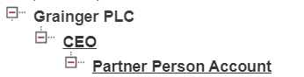

Recommendations for Sharing Model
- Review all objects with external Read/Write access
- Use Sharing Rules to share records with external and internal users wherever possible.

Allowed Email Domains
Currently disabled.

Allowed Email Domains Recommendations
None

Single Sign-On and Multifactor Authentication (MFA)
Grainger does not use Salesforce MFA.

Single Sign-On and Multifactor Authentication (MFA) Recommendations
None

User Provisioning
Users are being provisioned via SSO Identity provider Microsoft online

User Provisioning Observations
- As per system audit trail, there seems to be an absence of procedure for deactivating users. Deactivated users hold the record ownership which might cause issues with automation. e. g. process builders etc.

User Provisioning Recommendations
- Remove record ownership when deactivating users from Salesforce.
- Remove users from permission sets and permission set groups, approval processes when deactivating users.

Review of all declarative automations
The following tables document the automations within Grainger org

Approval Processes
Name | Object | Purpose/Description
Letting Agent Offer Approval Process | Quote | Launched by Offer_Send_for_Approval Flow, from the Letting Agent Portal in order to gain Grainger acceptance on an offer that the Customer has made to the Letting Agent.
EoT Cancellation Approval Process | End_Of_Tenancy__c | https://graingerplc.atlassian.net/browse/FVVP-139

Workflow Rules
Name | Object | Purpose/Description | Can be converted to a Flow?
Attached xls - WFRules-PB-Flow xls Tab name – Workflow Rules

Process Builder
Name | Object | Purpose/Description | Can be converted to a Flow?
Attached xls - WFRules-PB-Flow.xls – Tab name – Process Builder

Flow
Name | Object | Purpose/Description
Attached xls - WFRules-PB-Flow.xls Check tab name - Flow

Observations
- There are a significant number of automations built with Process Builder and Workflow Rules
- Salesforce has communicated that Flow is the preferred declarative automation tool and will be the focus area for enhancements delivered in future releases. As a result of this they will cease the support of Workflow Rules and Process Builder automations from December 2025.
- While both Workflow Rules and Process Builder Automations will continue to work after December 2025, Salesforce will not be supporting them - i.e. Salesforce support will not assist with any issues related to workflow rules or process builder. In the event that an issue arises with workflow rule or process builder (e.g. due to new functionality developed by GDSO or a Salesforce release) after December 2025, Hines may need to convert it to a Flow in order to resolve the issue. In the scenario that this was a critical issue, it would put undue pressure on the team to convert the legacy automation to a Flow and complete the necessary testing before deploying to production.
- Add fault path to handle exceptions gracefully in all the existing flows

Recommendations
- Identify which Workflow Rules and Process Builder Automations are business critical and create a plan to convert them to Flow prior to December 2025. This can be done via a strategy where any changes (e.g. new requirements) to a business critical legacy automation would automatically require the automation to be converted to a Flow. Any non-business critical Workflow Rules and Process Builder Automations can remain, but should ideally be monitored during each subsequent Salesforce release and converted to Flow if required.
- Remove unused flows, workflow rules and process builders.

Apex Code

Code Quality

Observations
- Based on the results of Apex PMD static code analyser (see Appendix for full details) a number of issues have been flagged.
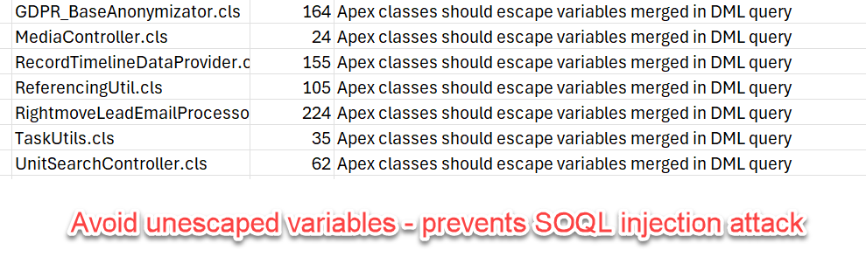
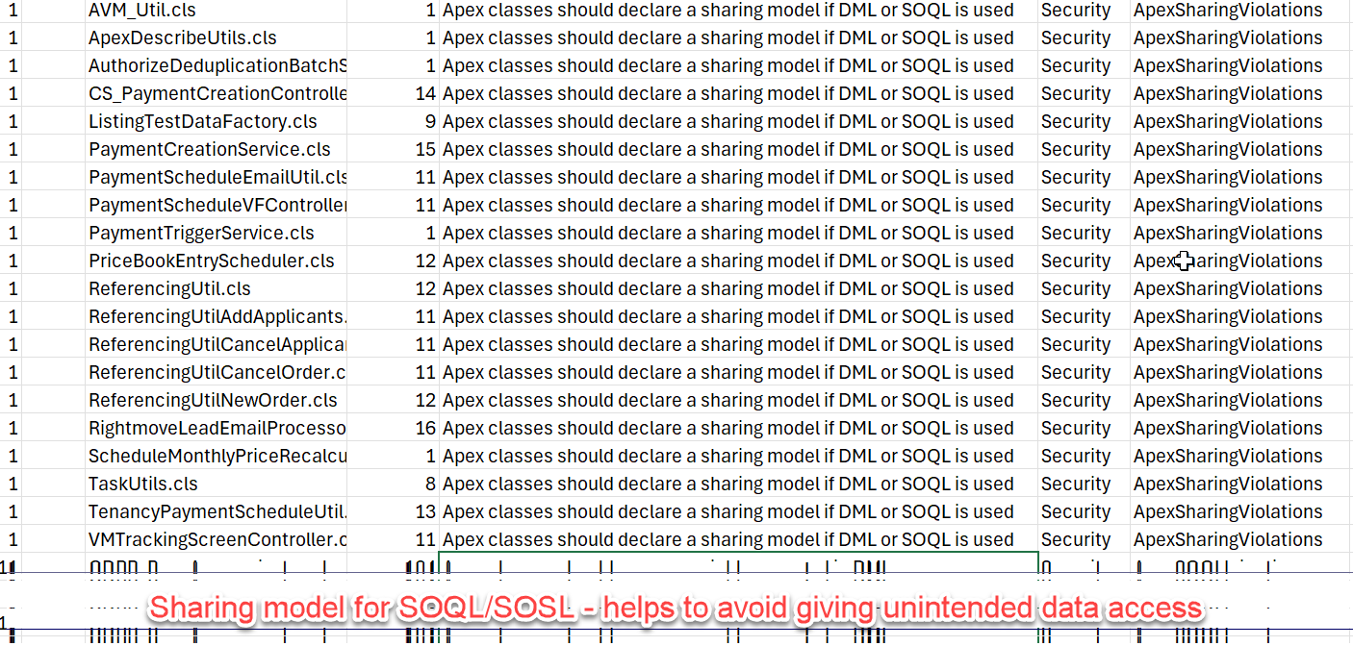
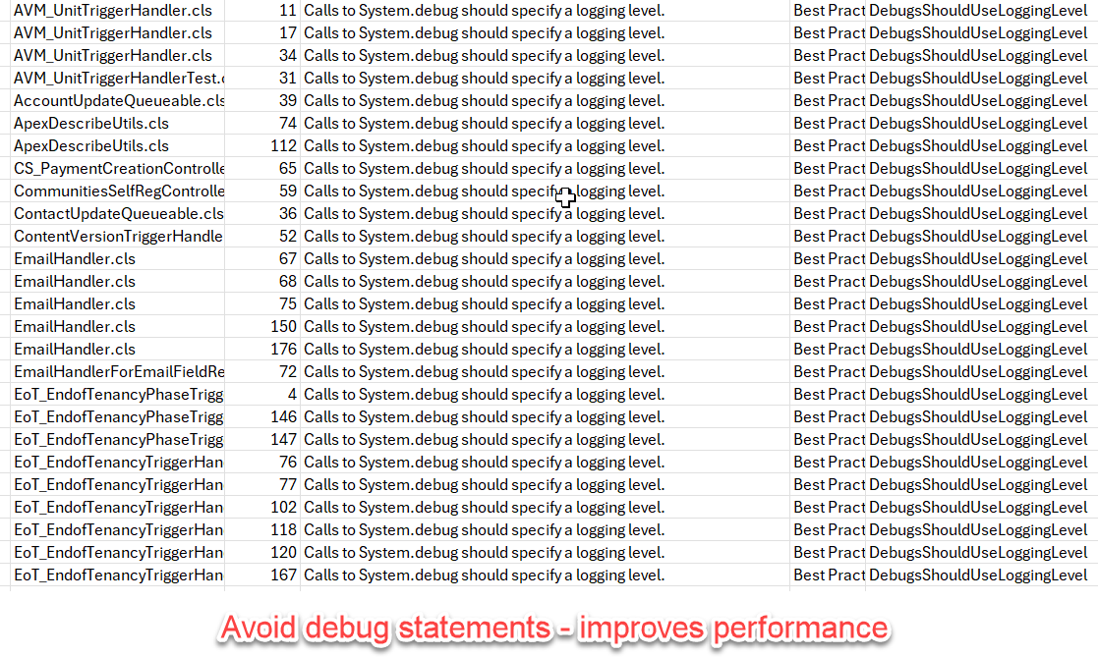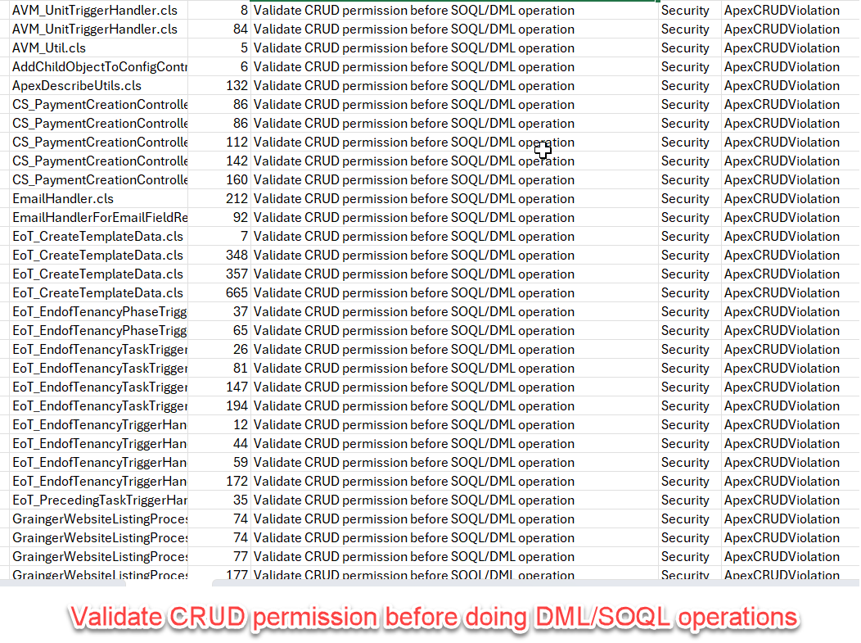

Apex Code Quality and Recommendations
It is not recommended that all issues in the PMD output need to be resolved as this would involve significant development work for little tangible value to the business. However, some of the more important issues could be included in a backlog and delivered over time to improve the robustness and quality of the code. Some candidate issues are shown below
- Check for empty try catch blocks and add proper error handling as per scenario
- Only one trigger per sObject

Apex Test Code Coverage

Observations
- Test code coverage is currently showing as 75% which is required to deploy to PROD.
- Test classes failures are mentioned in attached xls.

Recommendations
Recommendations are as follows:
- Fix failing test cases
- seeAllData =true must be removed from test classes
- Test methods with no assert statements should have at least one

Review of page layouts and general user experiences
Having a user focused org that is easy to navigate and intuitive to navigate is a key driver in user adoption of any system Salesforce or otherwise. It is through this lens that we have reviewed key pages and offer the following recommendations

Recommendations
- Opportunity(219) and Unit page(143) layouts have high number of fields included. These pages need review and rework.
- Fields with low usage should be reviewed.

Prepared By: Anjali Salecha (OpenBox)

Reviewed By:

